
FACULTY OF ELECTRONICS AND COMPUTER TECHNOLOGY AND ENGINEERING

SEM II - 2025/26
BERR 2243
DATABASE AND CLOUD SYSTEM

EXERCISE 8 REPORT

LECTURER NAME:
PROFESOR MADYA DR SOO YEW GUAN

No. | Student Name | Matrix No.
1 | IKMAL IMAN BIN MOHD YUSOF | B122410306
2 | MUHAMMAD ARIF SYAFIE BIN AGUS  SALEH | B022210116
3 | MUHAMMAD HAIKAL BIN ZULKIFLI | B122410348

Introduction

Objective

Procedure
Step 1: Architecting the Time-Series Collection in Cloud
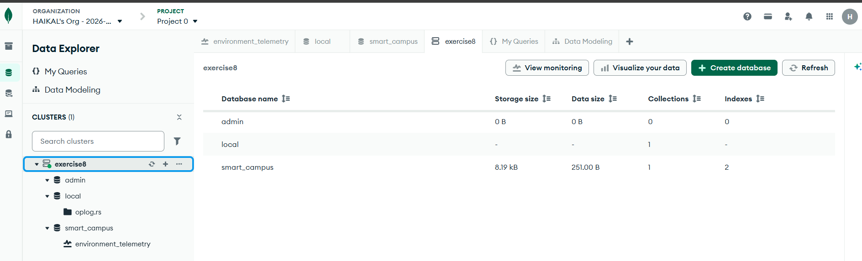

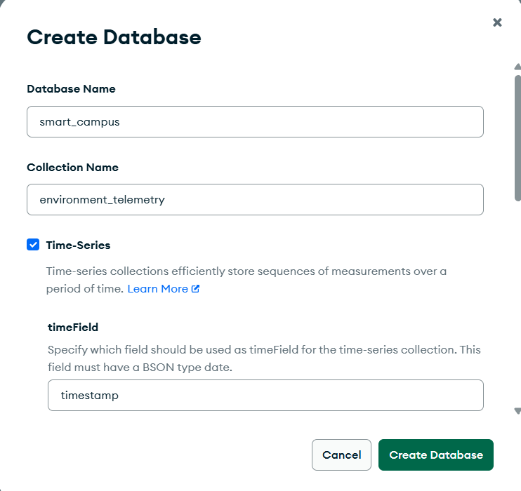
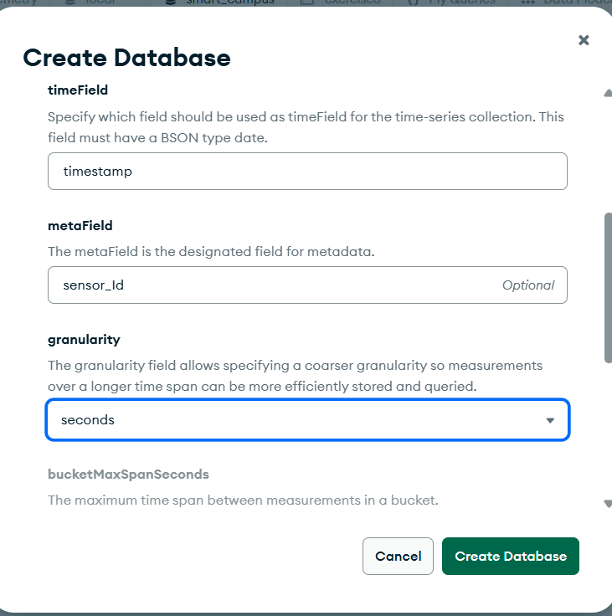
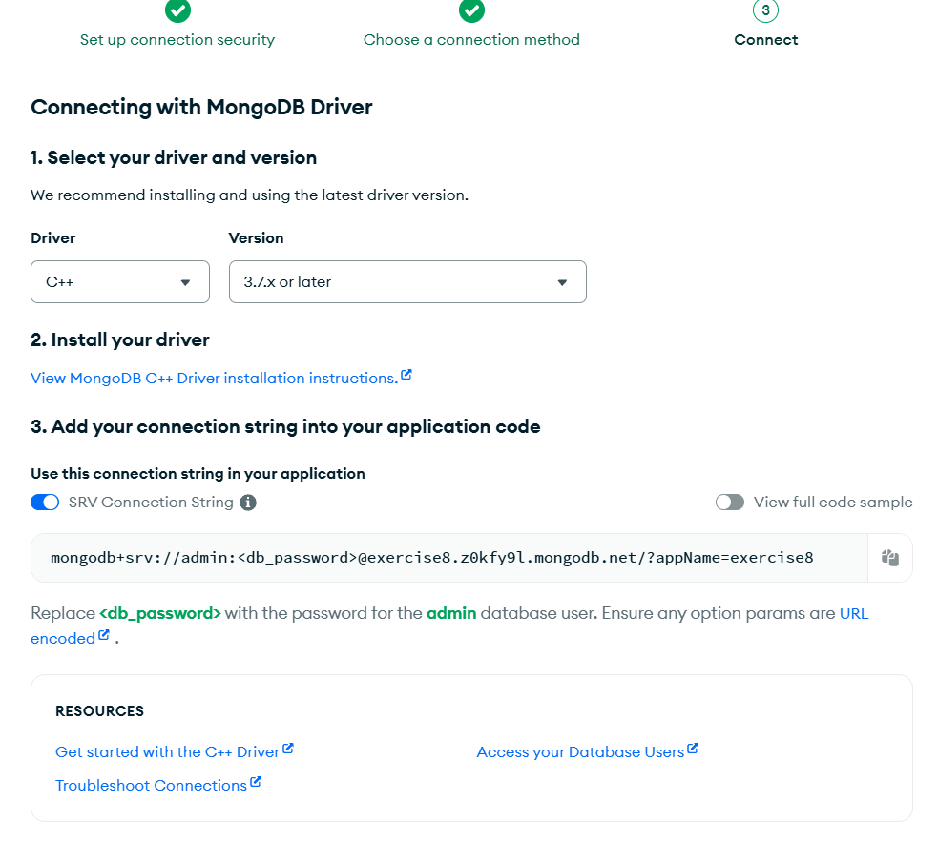

Step 2: Node-RED Middleware Transformation
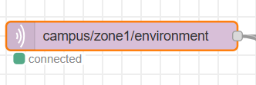
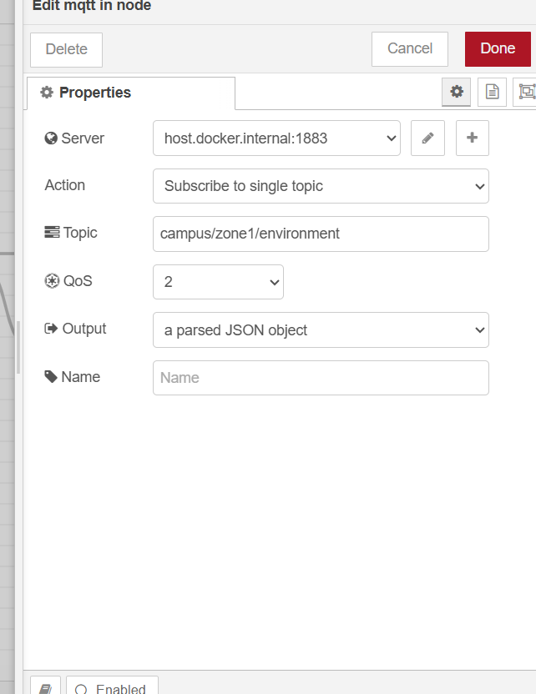
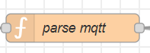
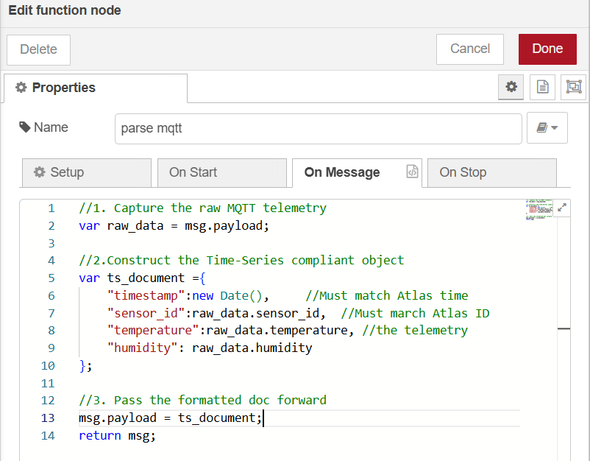
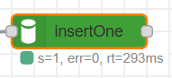
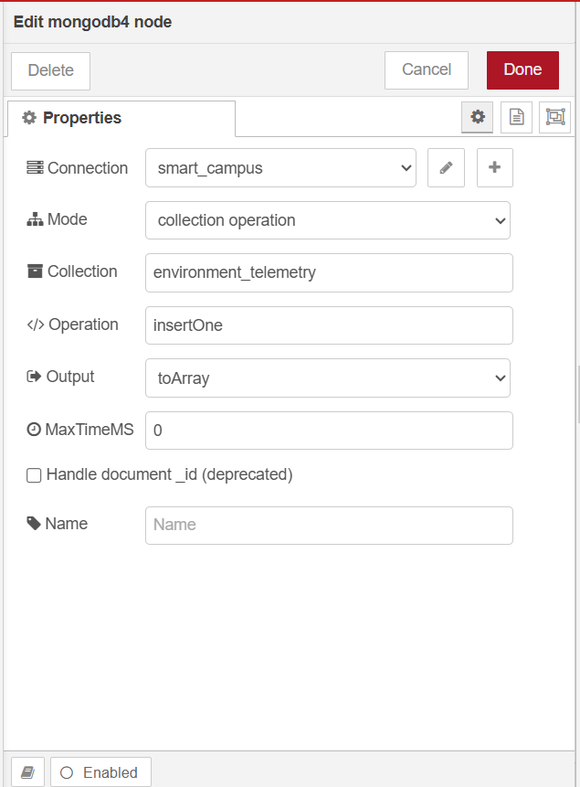
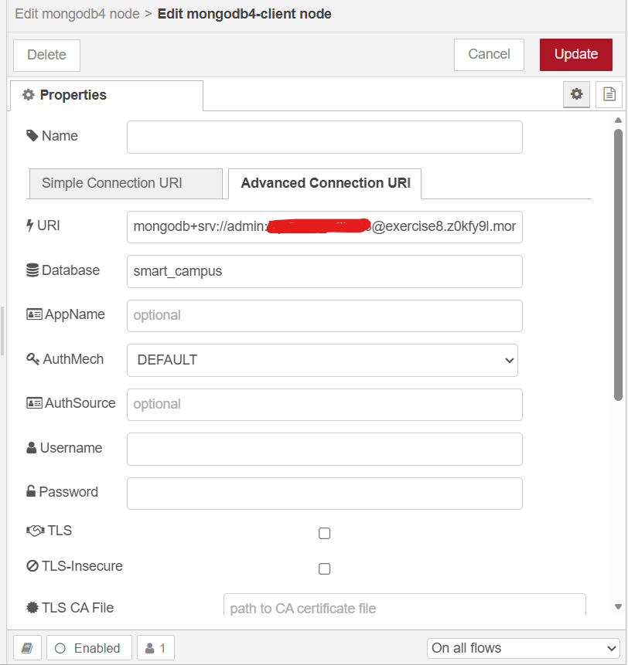
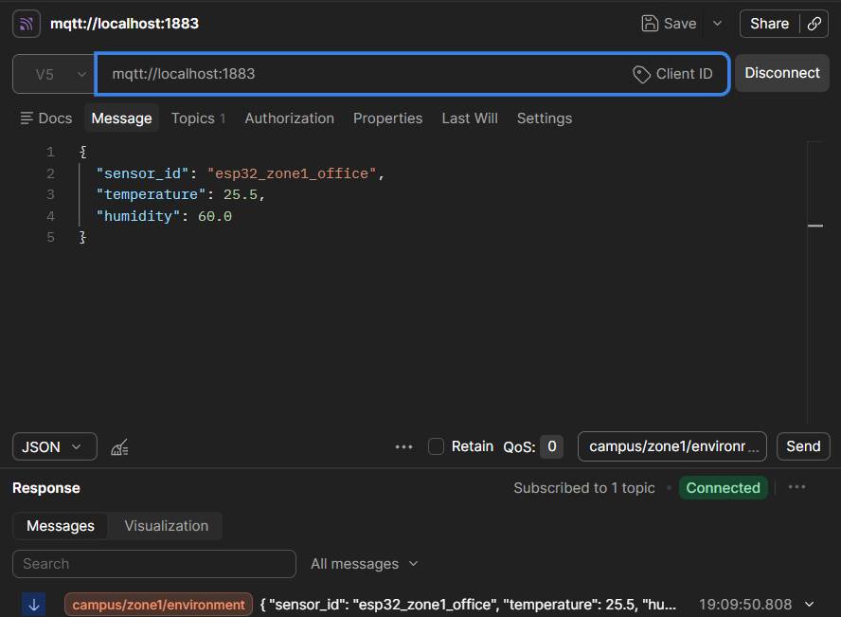

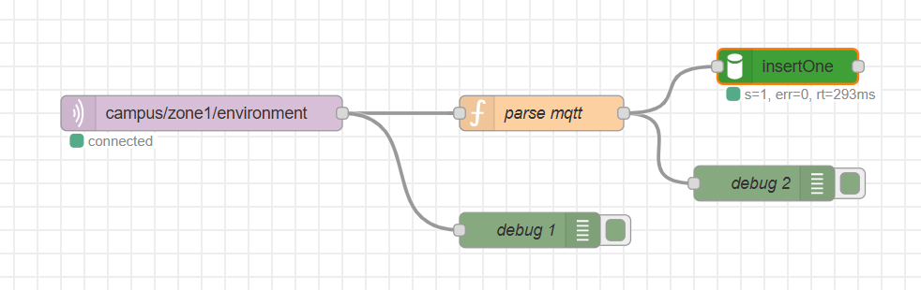
Step 3: Verifying Cloud Indexes and Bucket Storage
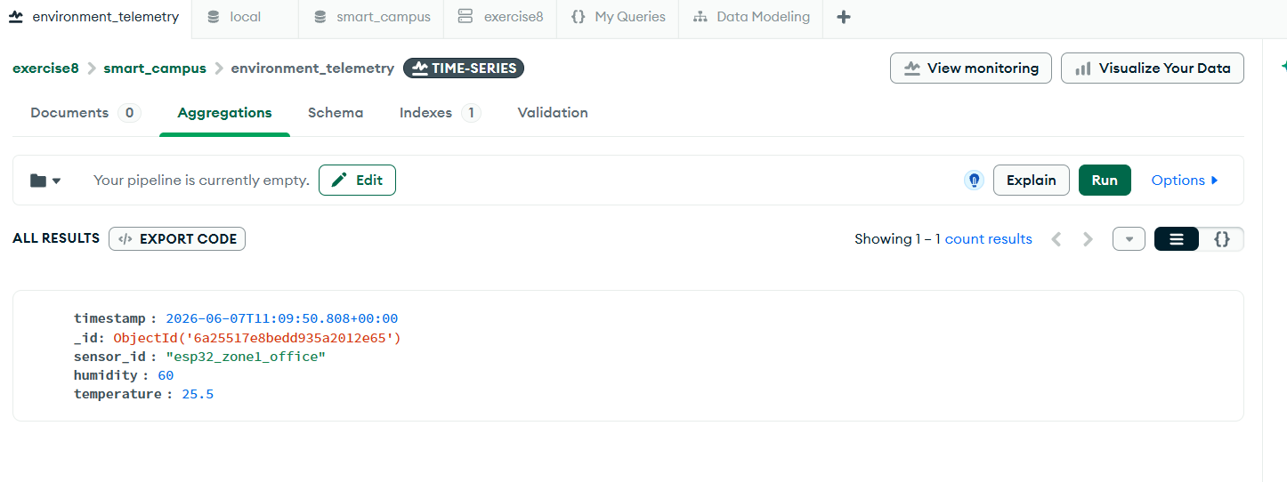
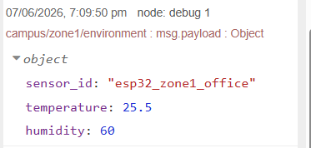
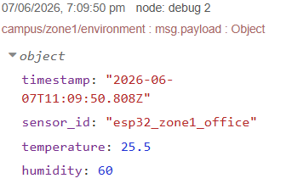
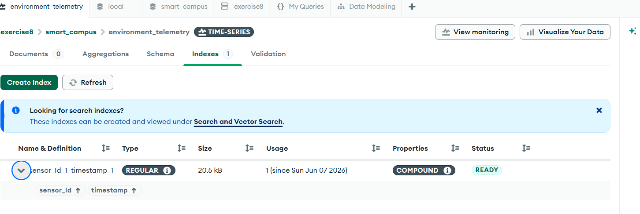
Discussion & Architecture Analysis
Question 1: The Definition of Metadata
When configuring the Time-Series collection, you explicitly set sensor_id as the metaField. Why must the metadata be a static identifier (like a MAC address, sensor name, or location) rather than the dynamic temperature reading? What would happen to the internal "Bucket Pattern" compression if you accidentally set the metaField to a variable that changes every second?

Question 2: Middleware vs. Edge Timestamping
In Step 2, you used a Javascript new Date() function inside Node-RED to stamp the exact time the message arrived at the server. Why is this server-side timestamping generally safer and more accurate than having the $5 ESP32 microcontroller generate the timestamp and send it inside the MQTT payload? (Hint: Consider the hardware limitations of microcontrollers regarding Real-Time Clocks (RTC) and battery loss).

Conclusion

